We are pleased to introduce the **descriptr** package, a set of tools for  
generating descriptive/summary statistics.

**Installation**

# Install release version from CRAN

install.packages("descriptr")

Library("descriptr")

**Shiny App**

**descriptr** includes a shiny app which can be launched using ds_launch_shiny_app()

**Data**

We have modified the mtcars data to create a new data set mtcarz. The only  
difference between the two data sets is related to the variable types.

str(mtcarz)

## 'data.frame': 32 obs. of 11 variables:

## $ mpg : num 21 21 22.8 21.4 18.7 18.1 14.3 24.4 22.8 19.2 ...

## $ cyl : Factor w/ 3 levels "4","6","8": 2 2 1 2 3 2 3 1 1 2 ...

## $ disp: num 160 160 108 258 360 ...

## $ hp : num 110 110 93 110 175 105 245 62 95 123 ...

## $ drat: num 3.9 3.9 3.85 3.08 3.15 2.76 3.21 3.69 3.92 3.92 ...

## $ wt : num 2.62 2.88 2.32 3.21 3.44 ...

## $ qsec: num 16.5 17 18.6 19.4 17 ...

## $ vs : Factor w/ 2 levels "0","1": 1 1 2 2 1 2 1 2 2 2 ...

## $ am : Factor w/ 2 levels "0","1": 2 2 2 1 1 1 1 1 1 1 ...

## $ gear: Factor w/ 3 levels "3","4","5": 2 2 2 1 1 1 1 2 2 2 ...

## $ carb: Factor w/ 6 levels "1","2","3","4",..: 4 4 1 1 2 1 4 2 2 4 ...

**Data Screening**

The ds_screener() function will screen a data set and return the following:  
– Column/Variable Names  
– Data Type  
– Levels (in case of categorical data)  
– Number of missing observations  
– % of missing observations

ds_screener(mtcarz)

## -----------------------------------------------------------------------

## | Column Name | Data Type | Levels | Missing | Missing (%) |

## -----------------------------------------------------------------------

## | mpg | numeric | NA | 0 | 0 |

## | cyl | factor | 4 6 8 | 0 | 0 |

## | disp | numeric | NA | 0 | 0 |

## | hp | numeric | NA | 0 | 0 |

## | drat | numeric | NA | 0 | 0 |

## | wt | numeric | NA | 0 | 0 |

## | qsec | numeric | NA | 0 | 0 |

## | vs | factor | 0 1 | 0 | 0 |

## | am | factor | 0 1 | 0 | 0 |

## | gear | factor | 3 4 5 | 0 | 0 |

## | carb | factor |1 2 3 4 6 8| 0 | 0 |

## -----------------------------------------------------------------------

##

## Overall Missing Values 0

## Percentage of Missing Values 0 %

## Rows with Missing Values 0

## Columns With Missing Values 0

**Continuous Data**

**Summary Statistics**

The ds_summary_stats() function returns a comprehensive set of statistics  
including measures of location, variation, symmetry and extreme observations.

ds_summary_stats(mtcarz, mpg)

## ------------------------------ Variable: mpg ------------------------------

##

## Univariate Analysis

##

## N 32.00 Variance 36.32

## Missing 0.00 Std Deviation 6.03

## Mean 20.09 Range 23.50

## Median 19.20 Interquartile Range 7.38

## Mode 10.40 Uncorrected SS 14042.31

## Trimmed Mean 19.95 Corrected SS 1126.05

## Skewness 0.67 Coeff Variation 30.00

## Kurtosis -0.02 Std Error Mean 1.07

##

## Quantiles

##

## Quantile Value

##

## Max 33.90

## 99% 33.44

## 95% 31.30

## 90% 30.09

## Q3 22.80

## Median 19.20

## Q1 15.43

## 10% 14.34

## 5% 12.00

## 1% 10.40

## Min 10.40

##

## Extreme Values

##

## Low High

##

## Obs Value Obs Value

## 15 10.4 20 33.9

## 16 10.4 18 32.4

## 24 13.3 19 30.4

## 7 14.3 28 30.4

## 17 14.7 26 27.3

You can pass multiple variables as shown below:

ds_summary_stats(mtcarz, mpg, disp)

## ------------------------------ Variable: mpg ------------------------------

##

## Univariate Analysis

##

## N 32.00 Variance 36.32

## Missing 0.00 Std Deviation 6.03

## Mean 20.09 Range 23.50

## Median 19.20 Interquartile Range 7.38

## Mode 10.40 Uncorrected SS 14042.31

## Trimmed Mean 19.95 Corrected SS 1126.05

## Skewness 0.67 Coeff Variation 30.00

## Kurtosis -0.02 Std Error Mean 1.07

##

## Quantiles

##

## Quantile Value

##

## Max 33.90

## 99% 33.44

## 95% 31.30

## 90% 30.09

## Q3 22.80

## Median 19.20

## Q1 15.43

## 10% 14.34

## 5% 12.00

## 1% 10.40

## Min 10.40

##

## Extreme Values

##

## Low High

##

## Obs Value Obs Value

## 15 10.4 20 33.9

## 16 10.4 18 32.4

## 24 13.3 19 30.4

## 7 14.3 28 30.4

## 17 14.7 26 27.3

##

##

##

## ------------------------------ Variable: disp -----------------------------

##

## Univariate Analysis

##

## N 32.00 Variance 15360.80

## Missing 0.00 Std Deviation 123.94

## Mean 230.72 Range 400.90

## Median 196.30 Interquartile Range 205.18

## Mode 275.80 Uncorrected SS 2179627.47

## Trimmed Mean 228.00 Corrected SS 476184.79

## Skewness 0.42 Coeff Variation 53.72

## Kurtosis -1.07 Std Error Mean 21.91

##

## Quantiles

##

## Quantile Value

##

## Max 472.00

## 99% 468.28

## 95% 449.00

## 90% 396.00

## Q3 326.00

## Median 196.30

## Q1 120.83

## 10% 80.61

## 5% 77.35

## 1% 72.53

## Min 71.10

##

## Extreme Values

##

## Low High

##

## Obs Value Obs Value

## 20 71.1 15 472

## 19 75.7 16 460

## 18 78.7 17 440

## 26 79 25 400

## 28 95.1 5 360

If you do not specify any variables, it will detect all the continuous  
variables in the data set and return summary statistics for each of them.

**Frequency Distribution**

The ds_freq_table() function creates frequency tables for continuous variables.  
The default number of intervals is 5.

ds_freq_table(mtcarz, mpg, 4)

## Variable: mpg

## |---------------------------------------------------------------------------|

## | Bins | Frequency | Cum Frequency | Percent | Cum Percent |

## |---------------------------------------------------------------------------|

## | 10.4 - 16.3 | 10 | 10 | 31.25 | 31.25 |

## |---------------------------------------------------------------------------|

## | 16.3 - 22.1 | 13 | 23 | 40.62 | 71.88 |

## |---------------------------------------------------------------------------|

## | 22.1 - 28 | 5 | 28 | 15.62 | 87.5 |

## |---------------------------------------------------------------------------|

## | 28 - 33.9 | 4 | 32 | 12.5 | 100 |

## |---------------------------------------------------------------------------|

## | Total | 32 | - | 100.00 | - |

## |---------------------------------------------------------------------------|

**Histogram**

A plot() method has been defined which will generate a histogram.

k <- ds_freq_table(mtcarz, mpg, 4)

plot(k)

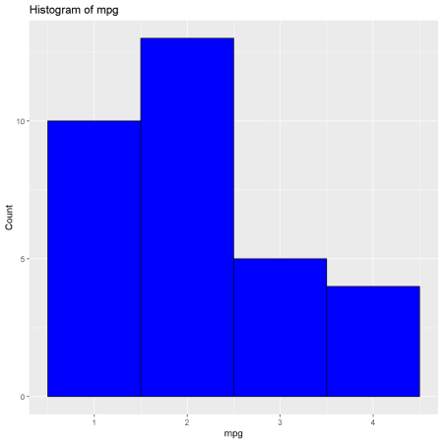

**Auto Summary**

If you want to view summary statistics and frequency tables of all or subset of  
variables in a data set, use ds_auto_summary().

ds_auto_summary_stats(mtcarz, disp, mpg)

## ------------------------------ Variable: disp -----------------------------

##

## ---------------------------- Summary Statistics ---------------------------

##

## ------------------------------ Variable: disp -----------------------------

##

## Univariate Analysis

##

## N 32.00 Variance 15360.80

## Missing 0.00 Std Deviation 123.94

## Mean 230.72 Range 400.90

## Median 196.30 Interquartile Range 205.18

## Mode 275.80 Uncorrected SS 2179627.47

## Trimmed Mean 228.00 Corrected SS 476184.79

## Skewness 0.42 Coeff Variation 53.72

## Kurtosis -1.07 Std Error Mean 21.91

##

## Quantiles

##

## Quantile Value

##

## Max 472.00

## 99% 468.28

## 95% 449.00

## 90% 396.00

## Q3 326.00

## Median 196.30

## Q1 120.83

## 10% 80.61

## 5% 77.35

## 1% 72.53

## Min 71.10

##

## Extreme Values

##

## Low High

##

## Obs Value Obs Value

## 20 71.1 15 472

## 19 75.7 16 460

## 18 78.7 17 440

## 26 79 25 400

## 28 95.1 5 360

##

##

##

## NULL

##

##

## -------------------------- Frequency Distribution -------------------------

##

## Variable: disp

## |---------------------------------------------------------------------------|

## | Bins | Frequency | Cum Frequency | Percent | Cum Percent |

## |---------------------------------------------------------------------------|

## | 71.1 - 151.3 | 12 | 12 | 37.5 | 37.5 |

## |---------------------------------------------------------------------------|

## | 151.3 - 231.5 | 5 | 17 | 15.62 | 53.12 |

## |---------------------------------------------------------------------------|

## | 231.5 - 311.6 | 6 | 23 | 18.75 | 71.88 |

## |---------------------------------------------------------------------------|

## | 311.6 - 391.8 | 5 | 28 | 15.62 | 87.5 |

## |---------------------------------------------------------------------------|

## | 391.8 - 472 | 4 | 32 | 12.5 | 100 |

## |---------------------------------------------------------------------------|

## | Total | 32 | - | 100.00 | - |

## |---------------------------------------------------------------------------|

##

##

## ------------------------------ Variable: mpg ------------------------------

##

## ---------------------------- Summary Statistics ---------------------------

##

## ------------------------------ Variable: mpg ------------------------------

##

## Univariate Analysis

##

## N 32.00 Variance 36.32

## Missing 0.00 Std Deviation 6.03

## Mean 20.09 Range 23.50

## Median 19.20 Interquartile Range 7.38

## Mode 10.40 Uncorrected SS 14042.31

## Trimmed Mean 19.95 Corrected SS 1126.05

## Skewness 0.67 Coeff Variation 30.00

## Kurtosis -0.02 Std Error Mean 1.07

##

## Quantiles

##

## Quantile Value

##

## Max 33.90

## 99% 33.44

## 95% 31.30

## 90% 30.09

## Q3 22.80

## Median 19.20

## Q1 15.43

## 10% 14.34

## 5% 12.00

## 1% 10.40

## Min 10.40

##

## Extreme Values

##

## Low High

##

## Obs Value Obs Value

## 15 10.4 20 33.9

## 16 10.4 18 32.4

## 24 13.3 19 30.4

## 7 14.3 28 30.4

## 17 14.7 26 27.3

##

##

##

## NULL

##

##

## -------------------------- Frequency Distribution -------------------------

##

## Variable: mpg

## |-----------------------------------------------------------------------|

## | Bins | Frequency | Cum Frequency | Percent | Cum Percent |

## |-----------------------------------------------------------------------|

## | 10.4 - 15.1 | 6 | 6 | 18.75 | 18.75 |

## |-----------------------------------------------------------------------|

## | 15.1 - 19.8 | 12 | 18 | 37.5 | 56.25 |

## |-----------------------------------------------------------------------|

## | 19.8 - 24.5 | 8 | 26 | 25 | 81.25 |

## |-----------------------------------------------------------------------|

## | 24.5 - 29.2 | 2 | 28 | 6.25 | 87.5 |

## |-----------------------------------------------------------------------|

## | 29.2 - 33.9 | 4 | 32 | 12.5 | 100 |

## |-----------------------------------------------------------------------|

## | Total | 32 | - | 100.00 | - |

## |-----------------------------------------------------------------------|

**Group Summary**

The ds_group_summary() function returns descriptive statistics of a continuous  
variable for the different levels of a categorical variable.

k <- ds_group_summary(mtcarz, cyl, mpg)

k

## mpg by cyl

## -----------------------------------------------------------------------------------------

## | Statistic/Levels| 4| 6| 8|

## -----------------------------------------------------------------------------------------

## | Obs| 11| 7| 14|

## | Minimum| 21.4| 17.8| 10.4|

## | Maximum| 33.9| 21.4| 19.2|

## | Mean| 26.66| 19.74| 15.1|

## | Median| 26| 19.7| 15.2|

## | Mode| 22.8| 21| 10.4|

## | Std. Deviation| 4.51| 1.45| 2.56|

## | Variance| 20.34| 2.11| 6.55|

## | Skewness| 0.35| -0.26| -0.46|

## | Kurtosis| -1.43| -1.83| 0.33|

## | Uncorrected SS| 8023.83| 2741.14| 3277.34|

## | Corrected SS| 203.39| 12.68| 85.2|

## | Coeff Variation| 16.91| 7.36| 16.95|

## | Std. Error Mean| 1.36| 0.55| 0.68|

## | Range| 12.5| 3.6| 8.8|

## | Interquartile Range| 7.6| 2.35| 1.85|

## -----------------------------------------------------------------------------------------

ds_group_summary() returns a tibble which can be used for further analysis.

k$tidy_stats

## # A tibble: 3 x 15

## cyl length min max mean median mode sd variance skewness

##

## 1 4 11 21.4 33.9 26.7 26 22.8 4.51 20.3 0.348

## 2 6 7 17.8 21.4 19.7 19.7 21 1.45 2.11 -0.259

## 3 8 14 10.4 19.2 15.1 15.2 10.4 2.56 6.55 -0.456

## # ... with 5 more variables: kurtosis , coeff_var ,

## # std_error , range , iqr

**Box Plot**

A plot() method has been defined for comparing distributions.

k <- ds_group_summary(mtcarz, cyl, mpg)

plot(k)

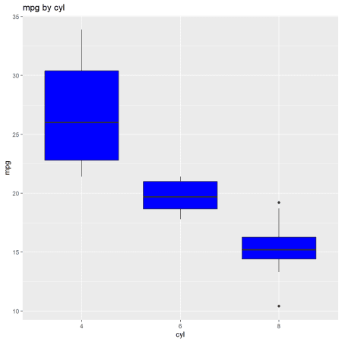

**Multiple Variables**

If you want grouped summary statistics for multiple variables in a data set, use  
ds_auto_group_summary().

ds_auto_group_summary(mtcarz, cyl, gear, mpg)

## mpg by cyl

## -----------------------------------------------------------------------------------------

## | Statistic/Levels| 4| 6| 8|

## -----------------------------------------------------------------------------------------

## | Obs| 11| 7| 14|

## | Minimum| 21.4| 17.8| 10.4|

## | Maximum| 33.9| 21.4| 19.2|

## | Mean| 26.66| 19.74| 15.1|

## | Median| 26| 19.7| 15.2|

## | Mode| 22.8| 21| 10.4|

## | Std. Deviation| 4.51| 1.45| 2.56|

## | Variance| 20.34| 2.11| 6.55|

## | Skewness| 0.35| -0.26| -0.46|

## | Kurtosis| -1.43| -1.83| 0.33|

## | Uncorrected SS| 8023.83| 2741.14| 3277.34|

## | Corrected SS| 203.39| 12.68| 85.2|

## | Coeff Variation| 16.91| 7.36| 16.95|

## | Std. Error Mean| 1.36| 0.55| 0.68|

## | Range| 12.5| 3.6| 8.8|

## | Interquartile Range| 7.6| 2.35| 1.85|

## -----------------------------------------------------------------------------------------

##

##

##

## mpg by gear

## -----------------------------------------------------------------------------------------

## | Statistic/Levels| 3| 4| 5|

## -----------------------------------------------------------------------------------------

## | Obs| 15| 12| 5|

## | Minimum| 10.4| 17.8| 15|

## | Maximum| 21.5| 33.9| 30.4|

## | Mean| 16.11| 24.53| 21.38|

## | Median| 15.5| 22.8| 19.7|

## | Mode| 10.4| 21| 15|

## | Std. Deviation| 3.37| 5.28| 6.66|

## | Variance| 11.37| 27.84| 44.34|

## | Skewness| -0.09| 0.7| 0.56|

## | Kurtosis| -0.38| -0.77| -1.83|

## | Uncorrected SS| 4050.52| 7528.9| 2462.89|

## | Corrected SS| 159.15| 306.29| 177.37|

## | Coeff Variation| 20.93| 21.51| 31.15|

## | Std. Error Mean| 0.87| 1.52| 2.98|

## | Range| 11.1| 16.1| 15.4|

## | Interquartile Range| 3.9| 7.08| 10.2|

## -----------------------------------------------------------------------------------------

**Multiple Variable Statistics**

The ds_tidy_stats() function returns summary/descriptive statistics for  
variables in a data frame/tibble.

ds_tidy_stats(mtcarz, mpg, disp, hp)

## # A tibble: 3 x 16

## vars min max mean t_mean median mode range variance stdev skew

##

## 1 disp 71.1 472 231. 228 196. 276. 401. 15361. 124. 0.420

## 2 hp 52 335 147. 144. 123 110 283 4701. 68.6 0.799

## 3 mpg 10.4 33.9 20.1 20.0 19.2 10.4 23.5 36.3 6.03 0.672

## # ... with 5 more variables: kurtosis , coeff_var , q1 ,

## # q3 , iqrange

**Measures**

If you want to view the measure of location, variation, symmetry, percentiles  
and extreme observations as tibbles, use the below functions. All of them,  
except for ds_extreme_obs() will work with single or multiple variables. If  
you do not specify the variables, they will return the results for all the  
continuous variables in the data set.

**Measures of Location**

ds_measures_location(mtcarz)

## # A tibble: 6 x 5

## var mean trim_mean median mode

##

## 1 disp 231. 228 196. 276.

## 2 drat 3.60 3.58 3.70 3.07

## 3 hp 147. 144. 123 110

## 4 mpg 20.1 20.0 19.2 10.4

## 5 qsec 17.8 17.8 17.7 17.0

## 6 wt 3.22 3.20 3.32 3.44

**Measures of Variation**

ds_measures_variation(mtcarz)

## # A tibble: 6 x 7

## var range iqr variance sd coeff_var std_error

##

## 1 disp 401. 205. 15361. 124. 53.7 21.9

## 2 drat 2.17 0.840 0.286 0.535 14.9 0.0945

## 3 hp 283 83.5 4701. 68.6 46.7 12.1

## 4 mpg 23.5 7.38 36.3 6.03 30.0 1.07

## 5 qsec 8.40 2.01 3.19 1.79 10.0 0.316

## 6 wt 3.91 1.03 0.957 0.978 30.4 0.173

**Measures of Symmetry**

ds_measures_symmetry(mtcarz)

## # A tibble: 6 x 3

## var skewness kurtosis

##

## 1 disp 0.420 -1.07

## 2 drat 0.293 -0.450

## 3 hp 0.799 0.275

## 4 mpg 0.672 -0.0220

## 5 qsec 0.406 0.865

## 6 wt 0.466 0.417

**Percentiles**

ds_percentiles(mtcarz)

## # A tibble: 6 x 12

## var min per1 per5 per10 q1 median q3 per95 per90 per99

##

## 1 disp 71.1 72.5 77.4 80.6 121. 196. 326 449 396. 468.

## 2 drat 2.76 2.76 2.85 3.01 3.08 3.70 3.92 4.31 4.21 4.78

## 3 hp 52 55.1 63.6 66 96.5 123 180 254. 244. 313.

## 4 mpg 10.4 10.4 12.0 14.3 15.4 19.2 22.8 31.3 30.1 33.4

## 5 qsec 14.5 14.5 15.0 15.5 16.9 17.7 18.9 20.1 20.0 22.1

## 6 wt 1.51 1.54 1.74 1.96 2.58 3.32 3.61 5.29 4.05 5.40

## # ... with 1 more variable: max

**Categorical Data**

**Cross Tabulation**

The ds_cross_table() function creates two way tables of categorical variables.

ds_cross_table(mtcarz, cyl, gear)

## Cell Contents

## |---------------|

## | Frequency |

## | Percent |

## | Row Pct |

## | Col Pct |

## |---------------|

##

## Total Observations: 32

##

## ----------------------------------------------------------------------------

## | | gear |

## ----------------------------------------------------------------------------

## | cyl | 3 | 4 | 5 | Row Total |

## ----------------------------------------------------------------------------

## | 4 | 1 | 8 | 2 | 11 |

## | | 0.031 | 0.25 | 0.062 | |

## | | 0.09 | 0.73 | 0.18 | 0.34 |

## | | 0.07 | 0.67 | 0.4 | |

## ----------------------------------------------------------------------------

## | 6 | 2 | 4 | 1 | 7 |

## | | 0.062 | 0.125 | 0.031 | |

## | | 0.29 | 0.57 | 0.14 | 0.22 |

## | | 0.13 | 0.33 | 0.2 | |

## ----------------------------------------------------------------------------

## | 8 | 12 | 0 | 2 | 14 |

## | | 0.375 | 0 | 0.062 | |

## | | 0.86 | 0 | 0.14 | 0.44 |

## | | 0.8 | 0 | 0.4 | |

## ----------------------------------------------------------------------------

## | Column Total | 15 | 12 | 5 | 32 |

## | | 0.468 | 0.375 | 0.155 | |

## ----------------------------------------------------------------------------

If you want the above result as a tibble, use ds_twoway_table().

ds_twoway_table(mtcarz, cyl, gear)

## Joining, by = c("cyl", "gear", "count")

## # A tibble: 8 x 6

## cyl gear count percent row_percent col_percent

##

## 1 4 3 1 0.0312 0.0909 0.0667

## 2 4 4 8 0.25 0.727 0.667

## 3 4 5 2 0.0625 0.182 0.4

## 4 6 3 2 0.0625 0.286 0.133

## 5 6 4 4 0.125 0.571 0.333

## 6 6 5 1 0.0312 0.143 0.2

## 7 8 3 12 0.375 0.857 0.8

## 8 8 5 2 0.0625 0.143 0.4

A plot() method has been defined which will generate:

**Grouped Bar Plots**

k <- ds_cross_table(mtcarz, cyl, gear)

plot(k)

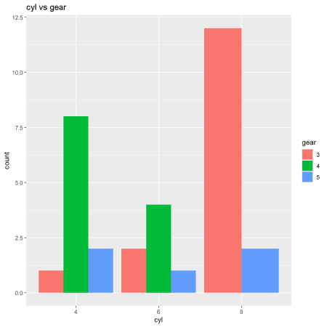

**Stacked Bar Plots**

k <- ds_cross_table(mtcarz, cyl, gear)

plot(k, stacked = TRUE)

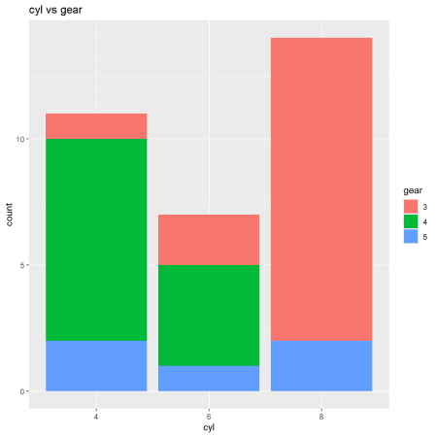

**Proportional Bar Plots**

k <- ds_cross_table(mtcarz, cyl, gear)

plot(k, proportional = TRUE)

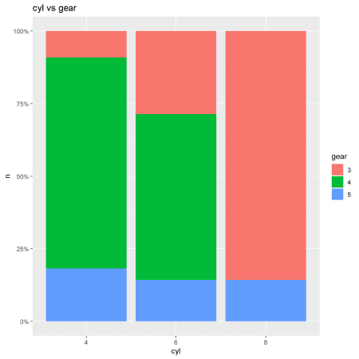

**Frequency Table**

The ds_freq_table() function creates frequency tables.

ds_freq_table(mtcarz, cyl)

## Variable: cyl

## -----------------------------------------------------------------------

## Levels Frequency Cum Frequency Percent Cum Percent

## -----------------------------------------------------------------------

## 4 11 11 34.38 34.38

## -----------------------------------------------------------------------

## 6 7 18 21.88 56.25

## -----------------------------------------------------------------------

## 8 14 32 43.75 100

## -----------------------------------------------------------------------

## Total 32 - 100.00 -

## -----------------------------------------------------------------------

A plot() method has been defined which will create a bar plot.

k <- ds_freq_table(mtcarz, cyl)

plot(k)

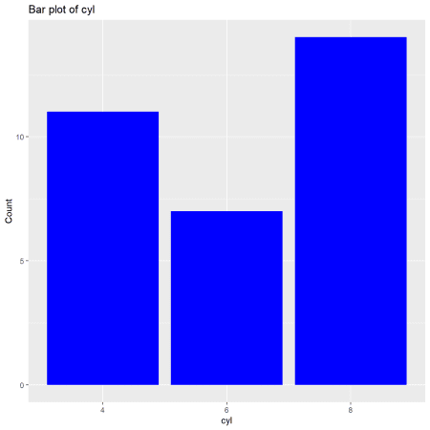

**Multiple One Way Tables**

The ds_auto_freq_table() function creates multiple one way tables by creating a  
frequency table for each categorical variable in a data set. You can also  
specify a subset of variables if you do not want all the variables in the data  
set to be used.

ds_auto_freq_table(mtcarz)

## Variable: cyl

## -----------------------------------------------------------------------

## Levels Frequency Cum Frequency Percent Cum Percent

## -----------------------------------------------------------------------

## 4 11 11 34.38 34.38

## -----------------------------------------------------------------------

## 6 7 18 21.88 56.25

## -----------------------------------------------------------------------

## 8 14 32 43.75 100

## -----------------------------------------------------------------------

## Total 32 - 100.00 -

## -----------------------------------------------------------------------

##

## Variable: vs

## -----------------------------------------------------------------------

## Levels Frequency Cum Frequency Percent Cum Percent

## -----------------------------------------------------------------------

## 0 18 18 56.25 56.25

## -----------------------------------------------------------------------

## 1 14 32 43.75 100

## -----------------------------------------------------------------------

## Total 32 - 100.00 -

## -----------------------------------------------------------------------

##

## Variable: am

## -----------------------------------------------------------------------

## Levels Frequency Cum Frequency Percent Cum Percent

## -----------------------------------------------------------------------

## 0 19 19 59.38 59.38

## -----------------------------------------------------------------------

## 1 13 32 40.62 100

## -----------------------------------------------------------------------

## Total 32 - 100.00 -

## -----------------------------------------------------------------------

##

## Variable: gear

## -----------------------------------------------------------------------

## Levels Frequency Cum Frequency Percent Cum Percent

## -----------------------------------------------------------------------

## 3 15 15 46.88 46.88

## -----------------------------------------------------------------------

## 4 12 27 37.5 84.38

## -----------------------------------------------------------------------

## 5 5 32 15.62 100

## -----------------------------------------------------------------------

## Total 32 - 100.00 -

## -----------------------------------------------------------------------

##

## Variable: carb

## -----------------------------------------------------------------------

## Levels Frequency Cum Frequency Percent Cum Percent

## -----------------------------------------------------------------------

## 1 7 7 21.88 21.88

## -----------------------------------------------------------------------

## 2 10 17 31.25 53.12

## -----------------------------------------------------------------------

## 3 3 20 9.38 62.5

## -----------------------------------------------------------------------

## 4 10 30 31.25 93.75

## -----------------------------------------------------------------------

## 6 1 31 3.12 96.88

## -----------------------------------------------------------------------

## 8 1 32 3.12 100

## -----------------------------------------------------------------------

## Total 32 - 100.00 -

## -----------------------------------------------------------------------

**Multiple Two Way Tables**

The ds_auto_cross_table() function creates multiple two way tables by creating a  
cross table for each unique pair of categorical variables in a data set. You  
can also specify a subset of variables if you do not want all the variables in  
the data set to be used.

ds_auto_cross_table(mtcarz, cyl, gear, am)

## Cell Contents

## |---------------|

## | Frequency |

## | Percent |

## | Row Pct |

## | Col Pct |

## |---------------|

##

## Total Observations: 32

##

## cyl vs gear

## ----------------------------------------------------------------------------

## | | gear |

## ----------------------------------------------------------------------------

## | cyl | 3 | 4 | 5 | Row Total |

## ----------------------------------------------------------------------------

## | 4 | 1 | 8 | 2 | 11 |

## | | 0.031 | 0.25 | 0.062 | |

## | | 0.09 | 0.73 | 0.18 | 0.34 |

## | | 0.07 | 0.67 | 0.4 | |

## ----------------------------------------------------------------------------

## | 6 | 2 | 4 | 1 | 7 |

## | | 0.062 | 0.125 | 0.031 | |

## | | 0.29 | 0.57 | 0.14 | 0.22 |

## | | 0.13 | 0.33 | 0.2 | |

## ----------------------------------------------------------------------------

## | 8 | 12 | 0 | 2 | 14 |

## | | 0.375 | 0 | 0.062 | |

## | | 0.86 | 0 | 0.14 | 0.44 |

## | | 0.8 | 0 | 0.4 | |

## ----------------------------------------------------------------------------

## | Column Total | 15 | 12 | 5 | 32 |

## | | 0.468 | 0.375 | 0.155 | |

## ----------------------------------------------------------------------------

##

##

## cyl vs am

## -------------------------------------------------------------

## | | am |

## -------------------------------------------------------------

## | cyl | 0 | 1 | Row Total |

## -------------------------------------------------------------

## | 4 | 3 | 8 | 11 |

## | | 0.094 | 0.25 | |

## | | 0.27 | 0.73 | 0.34 |

## | | 0.16 | 0.62 | |

## -------------------------------------------------------------

## | 6 | 4 | 3 | 7 |

## | | 0.125 | 0.094 | |

## | | 0.57 | 0.43 | 0.22 |

## | | 0.21 | 0.23 | |

## -------------------------------------------------------------

## | 8 | 12 | 2 | 14 |

## | | 0.375 | 0.062 | |

## | | 0.86 | 0.14 | 0.44 |

## | | 0.63 | 0.15 | |

## -------------------------------------------------------------

## | Column Total | 19 | 13 | 32 |

## | | 0.594 | 0.406 | |

## -------------------------------------------------------------

##

##

## gear vs am

## -------------------------------------------------------------

## | | am |

## -------------------------------------------------------------

## | gear | 0 | 1 | Row Total |

## -------------------------------------------------------------

## | 3 | 15 | 0 | 15 |

## | | 0.469 | 0 | |

## | | 1 | 0 | 0.47 |

## | | 0.79 | 0 | |

## -------------------------------------------------------------

## | 4 | 4 | 8 | 12 |

## | | 0.125 | 0.25 | |

## | | 0.33 | 0.67 | 0.38 |

## | | 0.21 | 0.62 | |

## -------------------------------------------------------------

## | 5 | 0 | 5 | 5 |

## | | 0 | 0.156 | |

## | | 0 | 1 | 0.16 |

## | | 0 | 0.38 | |

## -------------------------------------------------------------

## | Column Total | 19 | 13 | 32 |

## | | 0.594 | 0.406 | |

## -------------------------------------------------------------

**Visualization**

**descriptr** can help visualize multiple variables by automatically  
detecting their data types.

**Continuous Data**

ds_plot_scatter(mtcarz, mpg, disp, hp)

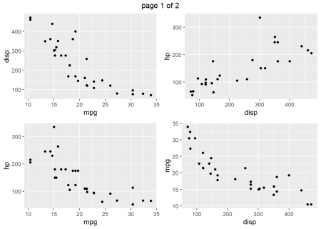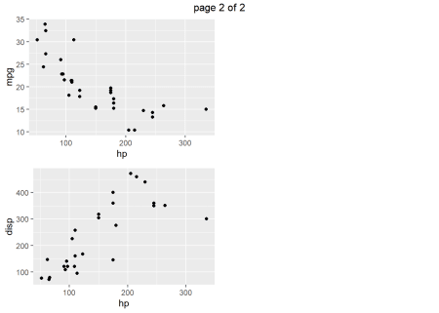

**Categorical Data**

ds_plot_bar_stacked(mtcarz, cyl, gear, am)

